
Traditional Pizza
All Pizzas $20 Per Person
Margherita
Tomato Base with Bocconcini & Basil
Capricciosa
Tomato, Cheese, Mushroom, Ham & Olives
Calabrese
Tomato, Cheese, Salami, Chili, Capsicum & Sausages
Napolitana
Tomato, Cheese, Anchovies, Oregano & Olives
Sicilia
Eggplant, Capsicum, Olives, Artichokes, Cheese, Cherry Tomatoes & Onion
Meat Lovers
Barbeque Sauce, Ham, Salami, Cabanossi & Cheese
Hawaiian
Tomato, Ham, Cheese & Pineapple
Supreme
Tomato, Cheese, Ham, Salami, Capsicum, Olives & Mushrooms
Marinara
Tomato & Cheese with Seafood Mix
Prosciutto
White base with Olive Oil, Bocconcini, Rucola, Prosciutto & Cherry Tomatoes

Peppe’s Pizza on Wheels
Peppe’s Pizza on Wheels
Peppe’s Pizza on Wheels
Catering Menu
Zeppole $5 P.P
Filled with Anchovies or Ham and Cheese

Arancini’s $10 P.P
Filled with Bolognese Sauce with Ham, Peas and Cheese
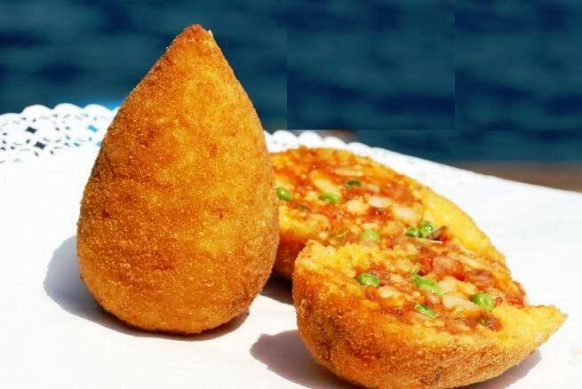
Porchetta $20 P.P
Served with Caponata and Bread rolls

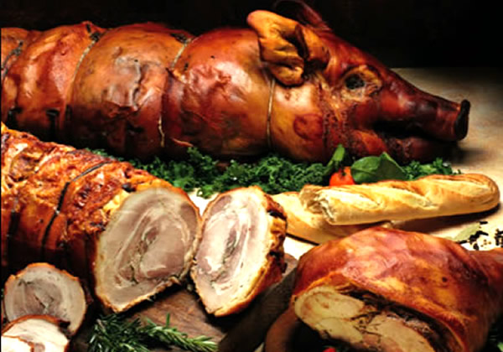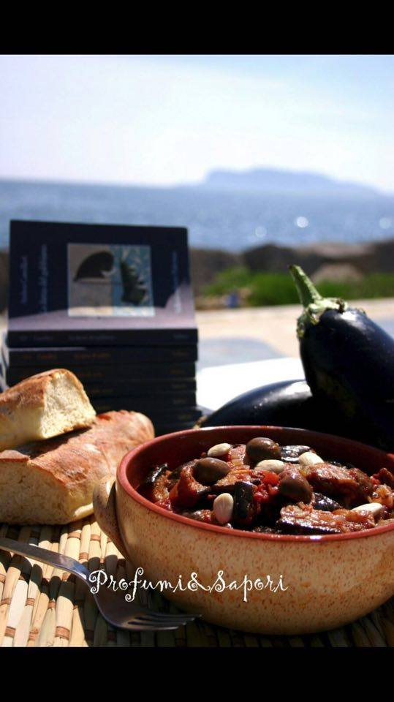

Entree
Garlic and Cheese Pizza
Pizza Base, Crushed Garlic and Cheese
Garlic Pizza
Pizza Base and Crushed Garlic
Bruschetta
Diced Tomato, Onion and Cheese

Dessert Pizza
Nutella
Strawberry, Nutella and Icing Sugar
Calzone Nutella
Strawberry, Banana and Nutella
Banana Split Pizza
Whipped Cream, Banana, Crushed Nuts and Chocolate Topping

